KEYAZ CONSULTANCY
MIDTERM II EXAMINATION 2023
Age Group (3 – 4 years): BABY CLASS
Learning Area 1: Social Development

My name is __________________________________________
- Oral work.
- What is your best colour?

- What do you use for writing?

- Where do Moslems go for prayers?

- What is your friend’s name?

- Who brings you at school?

- Who heads a family?

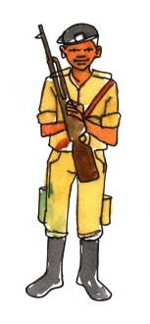
- Tell these important people.
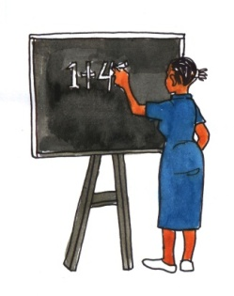

- Draw the things at home.


- Trace a mosque.

- Shade a baby.


END

